Map Building Station
Conversion of Kilometers and Miles
In this station, students will work on discovering the distances from place to place in both miles and kilometers. They will use Google Maps.

Directions
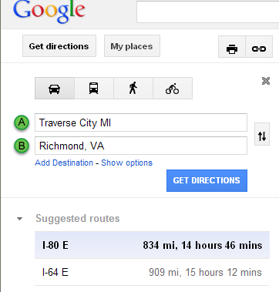
- Go to Internet Explorer. Go to www.google.com/maps.
- Go to the Directions Tab.
- Fill in the chart on your Measurement Lab sheet.
  - Fill in the two directions.
  - Click “Get Directions”
  - Record the distance it will take you in miles.
  - Then click on “Show options”
  - Change the measurement to km and click
Get Directions

  - Record the measurement in km.
- Continue the above steps for all the locations.
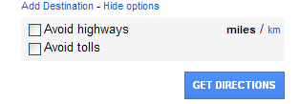
- Now find how many miles in 1 kilometer.
- Divide the number of kilometers by the number
of miles.
Example From Traverse City, Michigan to
Richmond, VA it is 1343km and 834mi.
1343 ÷834= 1.6 km per mile.
- Write a reflection telling me how kilometers compare to miles. Are they the same? Which one is longer? About how many kilometers are in 1 mile?

Temperature Station
In this station students will create a weather report with both Celsius and Fahrenheit. They will also graph their information on a graph.
- Assign roles to each person in your group. Two of you will create a weather report in Celsius and two will create a weather report in Fahrenheit.
- Use www.weather.com to create a 5 day weather forcast.
  - Enter www.weather.com into the internet browser.
  - In the top bar, It has a search option. Enter the zip code _____.
  - Go to 5 day weather.
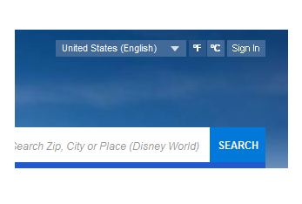
  - If you are completing the Celsius Graph go to the top of the page and click on to change to Celsius in the top right corner of the webpage.
  - Person 1 Record the information on the provided sheet of paper. Include Highs and Lows on your spreadsheet.
  - Click Expand Details and also record the moon phases.
  - Person 2 Record the information on a line graph. I have provided an example in the packet for you. 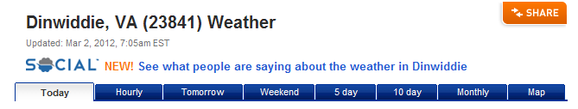
- Answer the reflection questions on your paper.

Weight Station
In this station students will make boats out of aluminum foil. They will weigh their boats in grams and ounces. Students will then add pennies to see how much weight their boats will hold.
- You are to create a boat out of aluminum foil to hold more pennies then your team mates. You may only use a 12 inch long piece of aluminum foil!
- Design your boat then weigh it using the two scales. The digital scale will weigh your boat in ounces and the balance scale will weigh it in grams.
- Measure 1 penny on both scales. Record that measurement.
- Now add pennies to your boat. Record the maximum number of pennies your boat can hold on your paper.
- Multiply the weight of 1 penny times your total number of pennies. (this is how much weight your boat will hold.)
- Answer the reflection questions.

Height Station
Students will investigate the differences between centimeters and inches using a real life problem.
The students from Mount Valley school are participating in a fund raiser for
their favorite charity. The students have decided to raise money by donating
one penny for each inch of their height. They measured their heights and
then challenged their Canadian pen pal school to measure their heights and
donate money to the same organization. The Canadian pen pal students
raised a lot more money. Investigate why this happened.
- Measure the height of each member in your group in inches.
- Record that measurement under the USA students’ height.
- Measure the height of each member in your group in centimeters.
- Record that measurement under the Canadian students heights.
- Find the total sum of inches and the total sum of centimeters.
- Find the amount of money donated to the fundraiser for USA and the Canadian heights.
- Answer the reflection questions.

Name__________________ Class_______________ Date______________

Measurement Lab Sheet

Map Building Station
Directions- Follow the directions on the direction cards.
- From | - To | - Miles | - Kilometers | - Kilometers ÷ Miles=
Richmond, VA | Traverse City, MI | 834 mi | 1343 km | 1.6 km/mi
Hot Springs, VA | Richmond, VA
Hot Springs, VA | Virginia Beach, VA
Hot Springs,VA | Atlanta, GA
Hot Springs, VA | (Anywhere you want.)
Reflection
- Look back at the kilometers and miles. Are kilometers the same distance as miles?

- Look at your column Kilometers ÷ Miles. How many kilometers are in 1 mile?

- Which is longer a kilometer or a mile?

- If you have extra time, choose your own locations and find the distance between them. Record your information on the blank spaces on your chart.

Temperature Station
Directions- Assign roles to each of you. Two of you will be completing the assignment using Celsius and two will complete the assignment using Fahrenheit.
 | Celsius Weather Report | Fahrenheit Weather Report
Student writing weather report
Student making Line graph

Your Role_______________
Your Temperature is (circle one) Celsius or Fahrenheit

 | Day 1 | Day 2 | Day 3 | Day 4 | Day 5
Day of the Week
High
Low
Moon Phase
If you are creating the line graph, use the graph page provided. Plot the high’s in one color and the lows in another color.
Compare the Celsius and Fahrenheit forecasts.
Reflection
- Does Celsius or Fahrenheit appear to be a greater temperature?

- What did you notice about the highs for the day on both line graphs? Were they the same?

- If they weren’t the same why do you think they weren’t?

- Explain why it is hard for us to understand the Celsius temperature. (Why do we think 25°C sounds really cold to us when it is actually 77°F and warm?)

Weight Station
Directions- You are to measure a sheet of aluminum foil that is 12 inches long. Then follow the directions on the direction cards.
 | Weight in Ounces | Weight in Grams
Your boat
Weight of 1 penny
Weight of 1 penny x the number of pennies in your boat.

How many pennies your boat held without filling with water. __________________

Reflection
- Find out how many grams are in 1 ounce. (Divide # of grams of pennies that fit in your boat by the number of ounces of pennies that will fit in your boat.
  - Grams ÷Ounces= ______________ grams/ounce
- Do you find it easier to imagine an ounce or to imagine the weight of a gram?

- What types of things would you measure in grams and ounces?

Height Station
Directions- Read the scenario then follow the directions on the direction cards.
Students Names | USA students  Height in Inches | Canadian Students  Height in Centimeters
Total Sum ____________ centimeters
Find the Average Height of your students.
______________ centimeters.
Amount of money donated to the fundraiser (1 penny per centimeter)
$______________
Total Sum ____________ inches.
Find the Average Height of your students.
______________ inches.
Amount of money donated to the fundraiser (1 penny per inch)
$______________

Reflection
- Why did the Canadian students raise so much more money?

- About how many centimeters are in an inch?

- How does this relate to the amount of money the Canadian students raised?

